Task-1
Draw a simple diagram (hand-drawn or digital) showing how your phone connects to Instagram, including your device, WiFi router, ISP, and Instagram server. Label each part and the connections.
Ans:

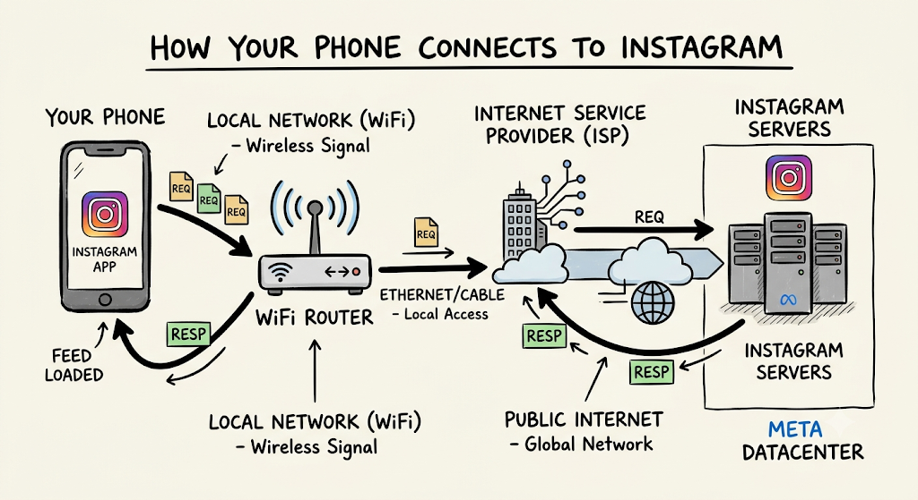

Task-2
List 5 devices you use or see daily that are part of a network (for example: smartphone, smart TV, WiFi router, laptop, smartwatch). For each, write what type of network it connects to (LAN, WAN, PAN, etc.).
Ans:
- Smartphone – Connects to WAN (via cellular network) and WLAN/LAN (via home Wi-Fi).

- Laptop – Connects to LAN/WLAN (via Wi-Fi router or Ethernet cable).

- Smartwatch – Connects to PAN (Personal Area Network via Bluetooth to a phone).

- Smart TV – Connects to LAN/WLAN (via home Wi-Fi to stream content locally and access the internet).

- Wi-Fi Router – Connects to LAN (internal home devices) and WAN (connects to the ISP and the wider internet).

Task-3
Explain the difference between the Internet and an intranet using an example from your college or a public WiFi you have used.
Ans:
The Internet is a global, public network accessible to anyone worldwide, while an Intranet is a private, restricted network accessible only to authorized members of a specific organization.
College Campus Example
- College Intranet (Private Network):
When you connect to the college Wi-Fi or computer lab network, you can access internal services like the student portal, internal attendance system, semester results, or digital library servers. These resources are hosted locally on the college network. Someone sitting at home cannot type that local IP/address into their browser and open it because access is restricted strictly to devices connected within the college campus.
- The Internet (Public Network):
While connected to the same college Wi-Fi, you open a browser to search on Google, watch a tutorial on YouTube, or check Wikipedia. Your device's request travels past the local college router, through an ISP, and out into the global network to fetch data from worldwide public servers.
Quick Comparison
Feature | Intranet (e.g., Campus Portal) | Internet (e.g., Public Web)
Accessibility | Restricted to authorized users (students/staff) | Open to anyone worldwide
Coverage | Localized (single campus/building) | Global (interconnected networks)
Security | High (protected by internal firewalls) | Variable (publicly exposed endpoints)
Ownership | Single organization (the college) | No single owner (decentralized)

Task-4
Pick any one app you use (like WhatsApp, Zomato, or Flipkart) and describe, in 4-5 lines, how data travels from your device to their server and back when you perform a search inside the app.<br><br><em><strong>Hint:</strong> Mention the devices and networks involved, and what happens when you hit 'search'.</em>
Ans:
How Data Travels in Flipkart (Search Flow)

- User Request: You type a product name in the Flipkart app and tap Search; your smartphone converts this query into an encrypted digital data packet.

- Local Network (LAN): The smartphone transmits the packet wirelessly over Wi-Fi (or 4G/5G mobile network) to your local router or cell tower.

- Public Network (WAN / ISP): Your Internet Service Provider (ISP) routes the data packet across the global internet through regional optical fiber lines and network routers.

- Server Processing: Flipkart’s cloud/data center server receives the packet, queries its database for matching products, and packages the results into a response.

- Data Return: The response travels back across the ISP, passes through your local router, and displays the product listings on your phone screen.

